Exercise 2 – Creating & Interpreting ERD Models

The purpose of this exercise is to be able to understand how data is stored in a relational database and how to implement ERDs as relational models.

# Part A – Completed with Instructor

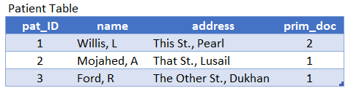Consider the following tables:

1. Complete a data dictionary for each of the 4 tables. Use the following as a template:

Table Name: PATIENT

|  |  |  |  |  |
| --- | --- | --- | --- | --- |
| **Column Name** | **Type** | **Key?** | **Restrictions** | **Description** |
| Pat_ID | INT | PK | >0, not null | Represents each patient record with an unique id |
| Name | Varchar(45) |  | Not null | Column for the name of patient |

* Create a data dictionary table for each table in the database shown.
* Types could be: integer, varchar(n), date, decimal(n,d)
* For the restrictions you can specify a range of values (i.e. positive integers), not null, etc.
* For the Key write either “PK” for primary key, “FK” for foreign key, or leave blank if there is no key. No need to identify other key types.
* For the description write just a brief explanation of what the column means.

1. Draw an ERD in MySQL Workbench that represents the tables shown.
   * You must use MySQL Workbench for this activity to receive any credit.
   * Arrange the entities to prevent (or at least minimize) line crossings.
   * Make sure the correct relationships are selected.
   * As is customary with MySQL database, lowercase letters are preferred with _ between words (i.e. emp_code).
   * Insert a picture of the ERD into your document and upload a copy of the **.mwb** file.
2. In a word document, answer the following questions based on the information shown in the table:
   1. What is (are) the name(s) of the patient(s) who had ‘emergency’ visit?
   2. What is (are) the name(s) of the patient(s) who visited ‘Hamad Medical Corp’?
   3. What would the tables look like if you hired a new doctor named ‘Al Thani’ who has been assigned to the ‘Sidra’ hospital and in the ‘Ophtalmology’ department? Show all the tables again (create them in Excel and paste the tables into your submission.
3. Draw the ERD using the draw.io online tool.

# Part B – Additional Exercises

Consider the ERD diagram shown below.

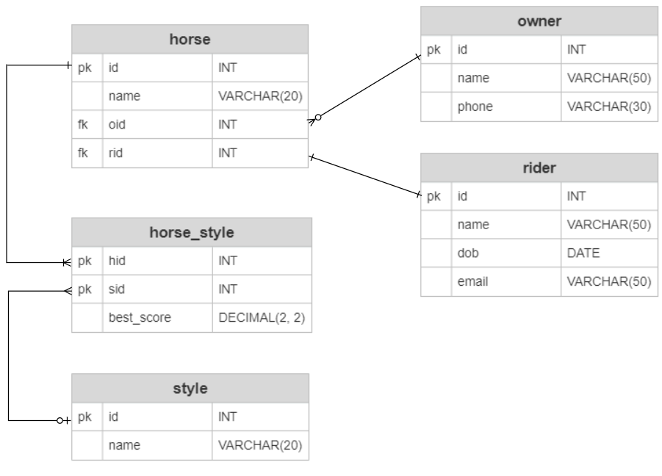

The “best_score” attribute in the horse_style entity is a value between 0 and 99.99 measuring the best score that a horse has received in a particular style. This field would allow for the user to ask questions like “which horse(s) have performed higher than 60 in Dressage?” where ‘Dressage’ is a riding style.

Your task is in this part is to create 5 tables with sample data like the tables shown in Part A of this exercise. You can use either Excel or Word to create the tables. You may use the Internet to find the most common riding styles such as ‘Dressage’ and ‘Show Jumping’ and ‘Barrel Racing.’

Follow these guidelines:

* You can make up the names of the horses. (e.g. Hermes, Athena’s Boy)
* There should be at least 5 horses.
* There should be at least 4 owners but not all owners should have a horse.
* There should be at least 5 styles.
* Some horses should have 2 or 3 styles and of course some styles should be known by multiple horses.
* At least one style should be known by no horses.
* While in the real world it is possible for one rider to ride different horses, and for one horse to be ridden by different jockeys, for this lab you may assume that each horse is assigned one particular jockey.